UltraVI80 - SpikeCheck Tool User Guide Nov18th14

Introduction

The SpikeCheck tool provides a convenient way to check a test program for excessive voltage levels that could potentially damage a DUT. Many companies require a test program to undergo a glitch or EOS (electrical overstress) check as part of the release to production process. This typically involves connecting a scope probe to each pin of the DUT one at a time and running the test program. A test engineer reviews the waveforms captured by the scope and is responsible for ensuring that the levels don’t exceed the device’s absolute maximum ratings.
Customers that perform this type of checking today typically do so when the test program is nearly complete and ready for production. This model of checking is extremely time consuming, as errors may be found in sections of code that have been essentially complete for months – the engineer responsible for the code in question may have moved on by the time these spikes are discovered.

The SpikeCheck Tool of UltraVI80 is intended to provide a test engineer the capability to check a test program for spikes on a daily basis without the need to locate an oscilloscope or probe around various hard-to-get locations on a DIB. This will simplify the process of checking for and catching most spikes, as well as allow them to be caught and fixed by the original authors of the test code while it is still fresh in their mind.
The SpikeCheck tool uses an integrated UltraVI80 functionality to verify the maximum levels applied to the DUT. The SpikeCheck tool uses input data from an input worksheet to accurately determine whether the DUT’s maximum ratings have been exceeded. The tool records the results of the check in an output worksheet in the test program. The tool results in a much more efficient and repeatable process that helps users meet more stringent product quality and cost requirements.

Theory of Operation

When the SpikeCheck Tool is enabled, it overrides the voltage clamp detect function and uses the voltage clamp comparators available on each UltraVI80 force line pin in order to detect any voltage spike. Dedicated registers will then latch and report spikes detected by the hardware.
When the test program execution starts, the tool programs the UltraVI80 channels clamp comparators thresholds to the values specified in the Settings sheet. When a test instance execution starts, the tool clears the registers used to report spikes detected by the hardware. When a test instance execution ends, the tool reads these registers to get the spikes that have been latched during the test instance execution. When the test program execution ends, the tool reset the UltraVI80 channels clamp comparators thresholds, compute and display the results in the Results sheet.
The SpikeCheck public VBT language used by this tool is described in this document under the section “SpikeCheck public VBT language”.

Notes:
- On UltraVI80, voltage and current clamping are both reported as mode alarm. Since the SpikeCheck Tool overrides the voltage clamp detect function, if the SpikeCheck tool is enabled for PinA and disabled for PinB, any current clamping will be reported for both PinA & PinB as mode alarm but any voltage clamping will be reported for PinB only.

- Spikes are deliberately detected only when channel’s Gate is On and Force Relay is Closed.

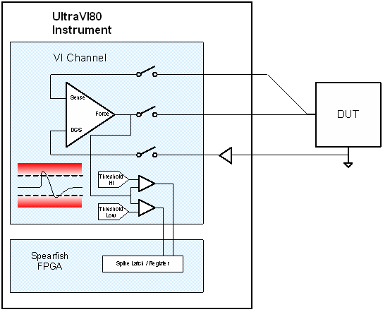
Overview

The tool’s basic features are:
- SpikeCheck Settings Sheet
- SpikeCheck Results Sheet
- SpikeCheck Toolbar

The SpikeCheck toolbar below is used to:
- Re-format existing SpikeCheck Sheets
- Insert new SpikeCheck Settings Sheet
- Enable the SpikeCheck Tool

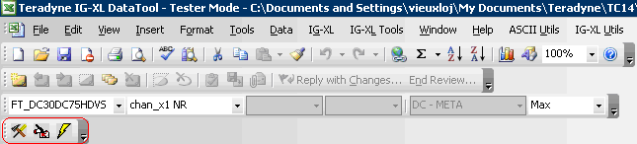

The Settings Sheet below is used to define pin specific settings such as the limit for the minimum and maximum voltage.

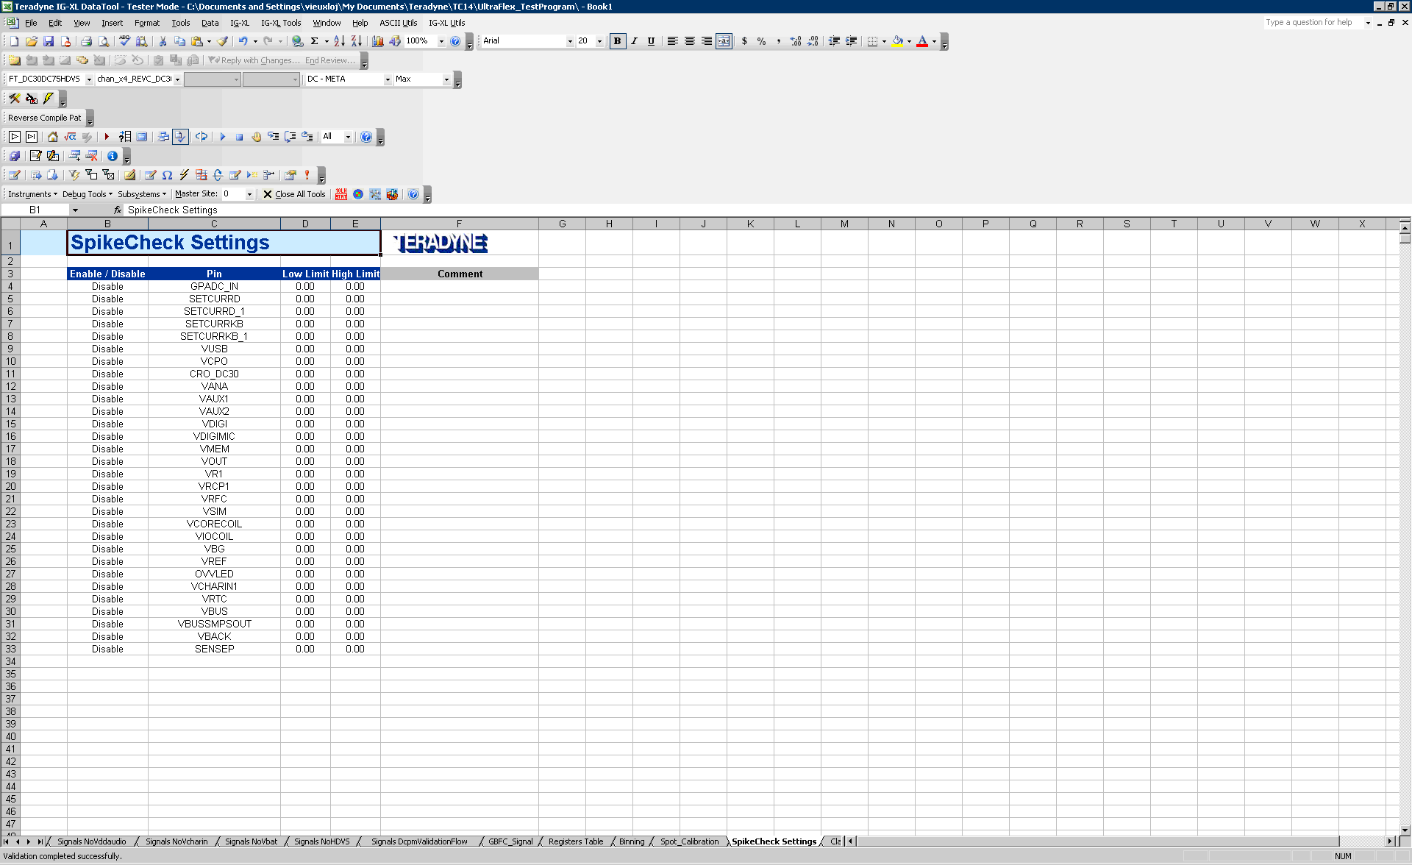

The Results Sheet below displays the results per pin and test instance and uses some color coding to easily see where voltage spikes occurred.

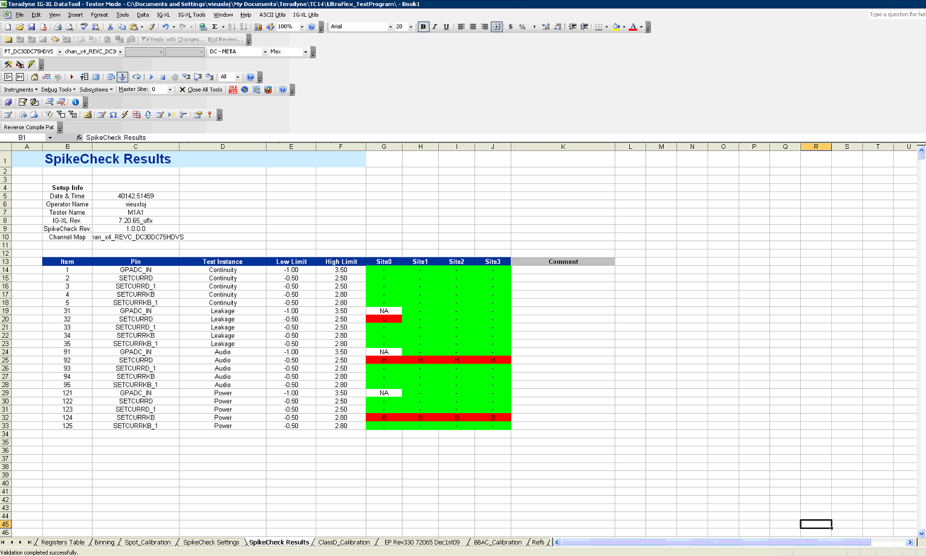
Requirements
The tool works with UltraFlex IG-XL 7.40 P2 or later and with UltraVI80 only.

Program Integration
No modification has to be made in the test program.

Impact on test program execution
The impact on the test program execution time depends on the number of sites, pins and test instances to check. However, the impact should only appear at test program start, end and between test instances. There isn’t any test time impact inside test instances.

Unsupported Cases
The tool does not support pins that are merged/unmerged during run time. These pins have to be disabled in the SpikeCheck Settings Sheet.

Known Issues
None at this time.

Usage Details

Prerequisites:

IGXL DataTool has to be running and the test program has to be validated to be able to use the SpikeCheck Tool.

If any of the 3 SpikeCheck Toolbar button is pressed while IGXL is not running, the following error message will pop up:

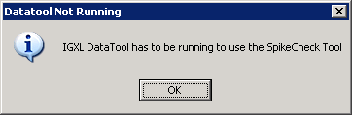

If any of the 3 SpikeCheck Toolbar button is pressed while the test program is not validated, the following error message will pop up:

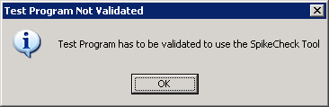

Step 1: Insert & Enter Information into Settings Sheet

In order to use the tool, the user must first insert a SpikeCheck Settings sheet. To do so, click on the 2nd button on the SpikeCheck Toolbar.

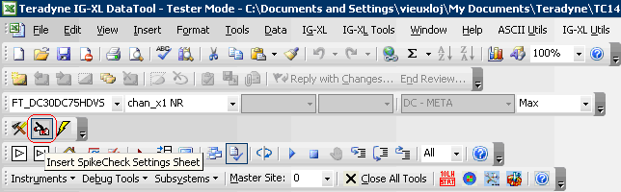

A Settings sheet will be inserted into the workbook, as shown below:

This sheet will be filled with default values for all the pins assigned to an UltraVI80 channel in the active Channel Map. The table below describes the SpikeCheck Settings sheet fields in detail.

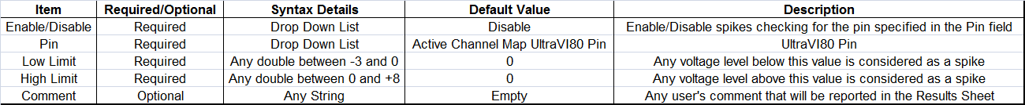

The user can then enable the spikes checking on a per pin basis, using the “Enable/Disable” drop down menu:

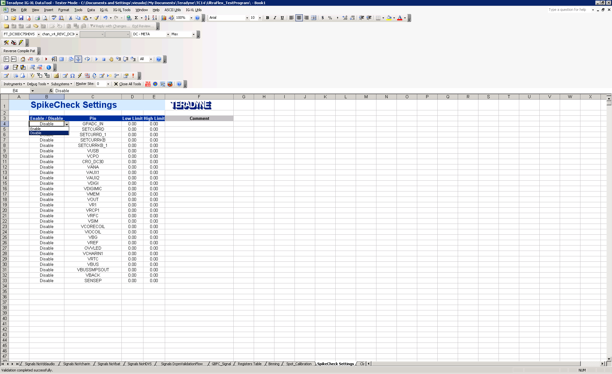

The user can also modify the Pin name using the “Pin” drop down menu:

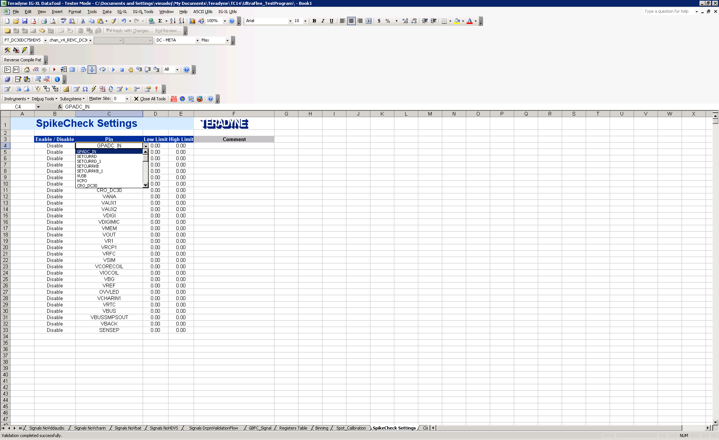

The SpikeCheck tool only gets its setup information from the one sheet with the name “SpikeCheck Settings.” The user can insert multiple setup sheets but obviously he must change the name of the sheets; only the one sheet with the name “SpikeCheck Settings” will be used by the tool. If the user presses the “Insert SpikeCheck Settings Sheet” button while a SpikeCheck Settings Sheet already exists, the following error message will pop up.

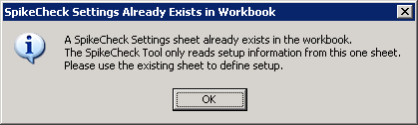

Step 2: Enable SpikeCheck Tool

To enable the tool, click on the 3rd button on the SpikeCheck Toolbar.

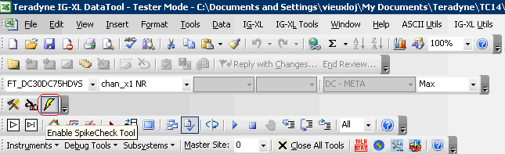

The tool then performs a validation of the Settings Sheet parameters. If there’s any issue with a parameter, an error message describing the problem will pop up:

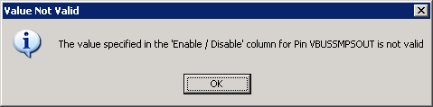

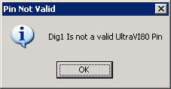

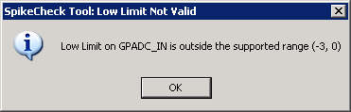

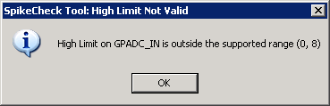

Otherwise, the button will remain pushed and the SpikeCheck Tool will be enabled.

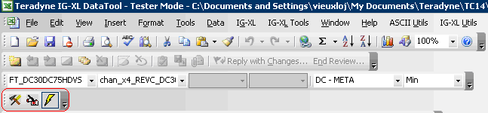

The SpikeCheck tool will remain enabled until the user disables it by pressing the “Enable SpikeCheck Tool” button or makes any modification to either the Settings sheet or the active Channel Map sheet.

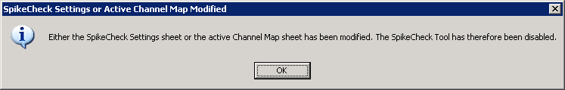

Step 3: Run Test Program

Once the SpikeCheck Tool is enabled, the only remaining thing to do is to run the test program.

During the test program run, the SpikeCheck Tool will perform different tasks.
A basic outline of the steps that occur when the tool is running is shown below:

On Test Run Start, the tool:
- enables the SpikeCheck functionality on the pins set as “Enabled” in the Settings sheet
- programs the UltraVI80 channels voltage clamp comparators to the min and max values specified in the Settings sheet

On Test Instance Start, the tool:
- clears the SpikeCheck registers used to latch and report Spikes

On Test Instance End, the tool:
- reads the SpikeCheck registers

On Test Run Stop, the tool:
- reset the UltraVI80 channels voltage clamp comparators values to 0
- disables the SpikeCheck functionality on the pins set as “Enabled” in the Settings sheet
- computes, displays and formats the results in the Results sheet

At the end of the test program execution, a Results sheet will be inserted into the workbook, as shown below.

This sheet displays the results per pin and test instance and uses some color coding to easily see where voltage spikes occurred.

The table below describes the “SpikeCheck Settings Sheet” fields in detail:

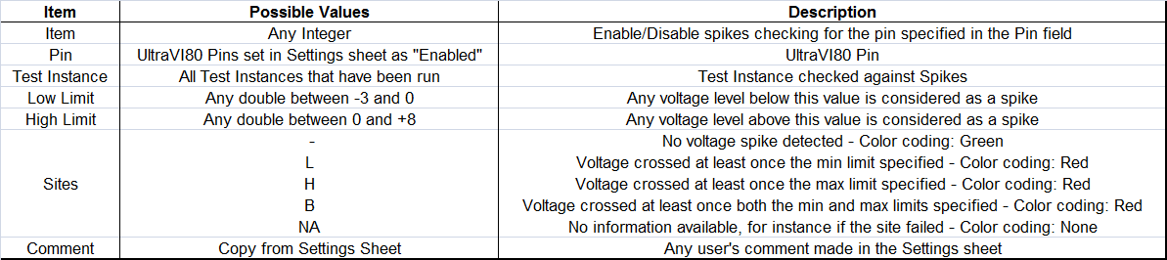

Additional Feature: SpikeCheck Tool Sheets Formatting

The SpikeCheck Tool Settings and Results sheets are just like any other sheet in the workbook; they can be saved with the workbook and they can be exported to ASCII. When the sheets are exported to ASCII, only the data are saved, the formatting (color coding, shapes, headers …) is therefore not preserved when these sheets are imported or loaded in IGXL:

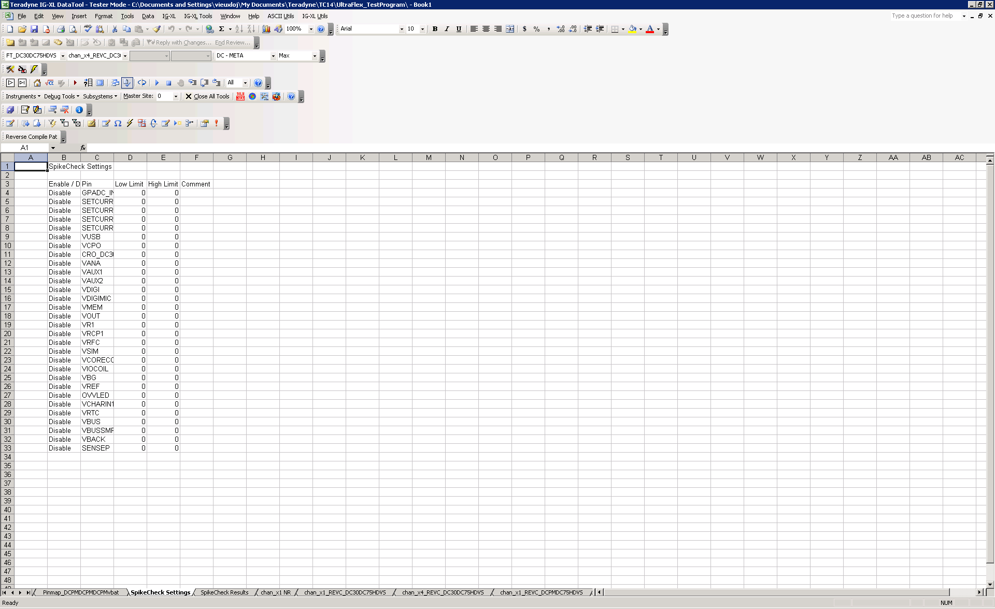

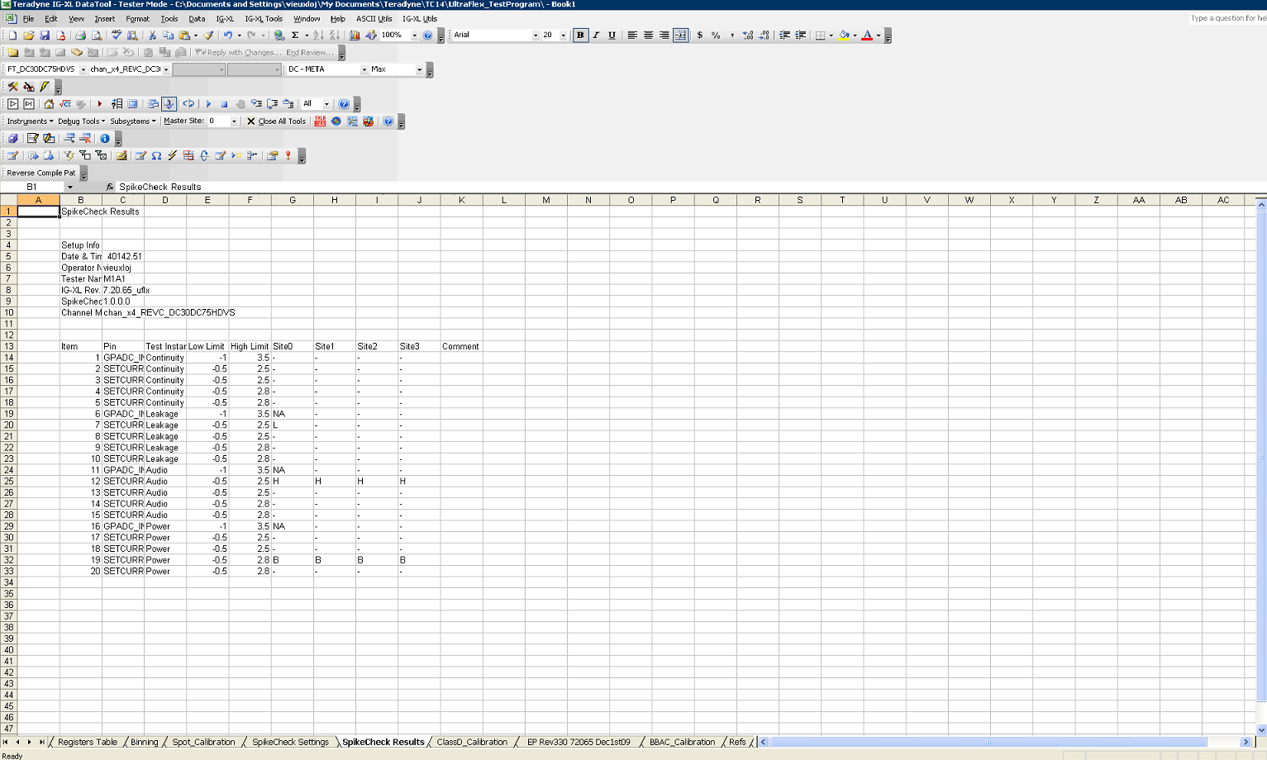
In order to retrieve the formatting for SpikeCheck Sheets imported from ASCII files, the SpikeCheck Toolbar provides the user with a “Format SpikeCheck Sheets” button (1st button on the SpikeCheck Toolbar)

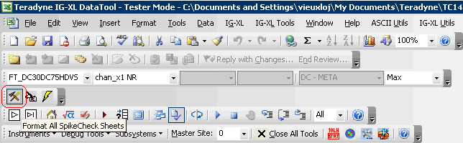

After clicking on this button, all the sheets in the workbook containing the string “SpikeCheck Settings” or “SpikeCheck Results” will be formatted as below:

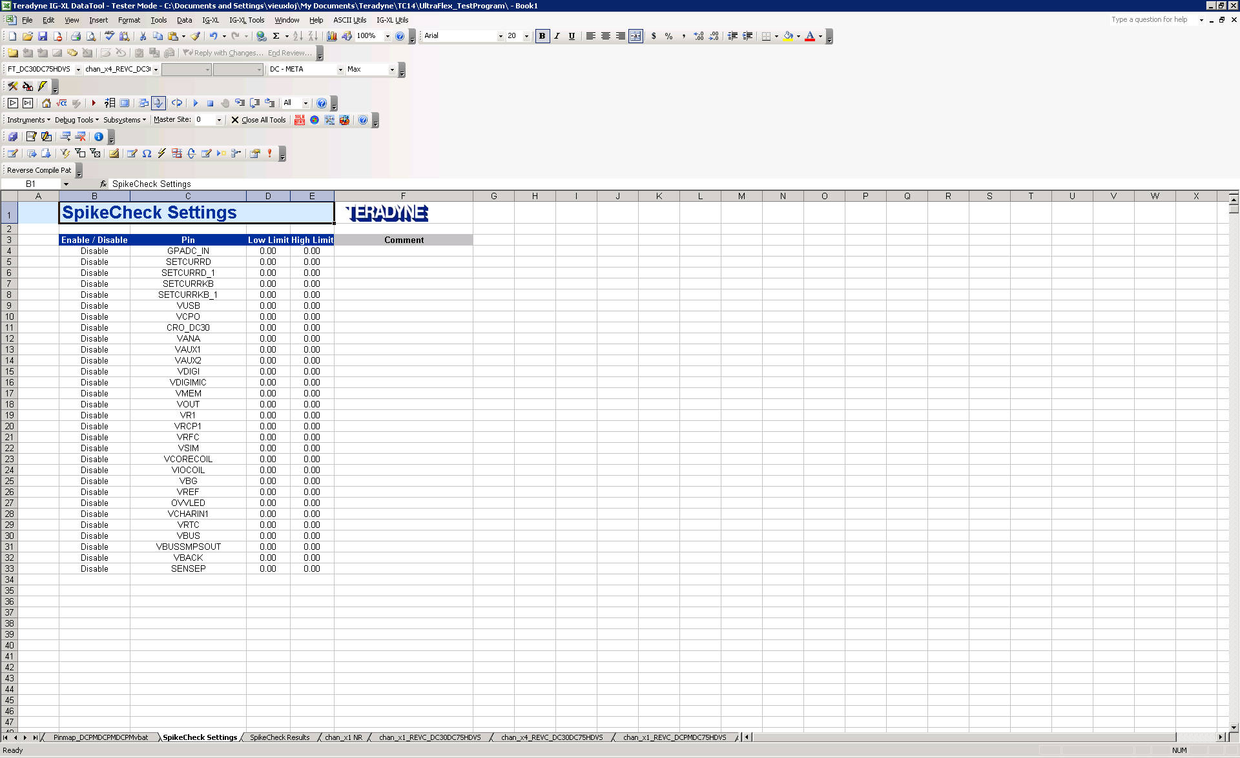

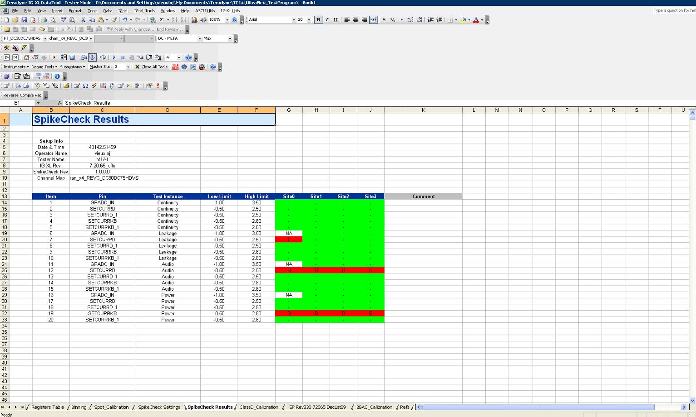

SpikeCheck public VBT language

The SpikeCheck Tool is using the following SpikeCheck public VBT language:

Setup
TheHdw.DCVI.SpikeCheck(PinList).Enable = <boolean>
TheHdw.DCVI.SpikeCheck(PinList).Levels.Min = <double>
TheHdw.DCVI.SpikeCheck(PinList).Levels.Max = <double>
TheHdw.DCVI.SpikeCheck(PinList). Clear

Readback
<PinListData> = TheHdw.DCVI.SpikeCheck(PinList).Read

This interface will return one of the following values to each PinListData element:
0 - tlDCVISpikeCheckNone
1 - tlDCVISpikeCheckCrossedMaxLevel
2 - tlDCVISpikeCheckCrossedMinLevel
3 - tlDCVISpikeCheckCrossedBothLevels

Status Readback
TheHdw.DCVI.SpikeCheck(PinList).AnySpikes
Returns True if a spike has been detected. Otherwise, returns False.

These instructions can also be used independently of the SpikeCheck Tool.

SpikeCheck Tool Package Revision History

Package_v1.0.7_Jan4th11
First release on eKnowledge
Shared Addin developped and built with VS2005
Supports IGXL 7.40.00 Px only

Package_v1.0.8_May4th11
Code ported to VS2010
Supports both IGXL 7.40.00 and 8.00 (and future revs) as well as the VersionSelector

Package_v1.0.9_July7th11
Bug fix to solve some issues with the toolbar not being displayed on some computers

Package_v1.1.0_May29th12
Changed the values for the Low and High Levels supported ranges from (-3,8) to:
- Low Level (-3,0)
- High Level (0,8)

Package_v1.1.1_July10th12
Fix for Case 368989. A tag ID is now appended at the end of each test instance name for every test instance calls in order to deal with flows containing multiple times the exact same Test Instance name.

Package_v1.1.2_Nov18th14
Fix for Case 403084. Fixed an issue that caused “-“ (Color Coding: Green – No Spikes) instead of “NA” (Color Coding: None – Not Available) to be reported on sites not selected to run in the Run Options.

